BE Cert Law 2022 Compliance for Log360

**Tagline** – Streamline BE Cert Law 2022 compliance with automated certificate and security monitoring using Log360.

**Overview**
The BE Cert Law 2022 Compliance extension for Log360 helps organizations align with Belgium's 2022 certification and security law requirements. By integrating this extension, IT and security teams gain comprehensive visibility into their certification compliance and security controls.
Log360 continuously collects and correlates log data from Active Directory, Windows, Unix/Linux, Microsoft 365, cloud platforms, and network devices, mapping events directly to BE Cert Law 2022 standards. Security teams can track compliance status in real time, investigate incidents quickly, and generate audit-ready reports with a single click.

**Key Features:**
- Generate comprehensive audit-reports mapped to all BE Cert Law 2022 certification requirements and controls.
- Automatically parses and normalizes log formats from Windows, Linux, firewalls, databases, and cloud platforms for analysis.
- Includes threat intelligence integration for identifying security violations and non-compliance indicators in logs.
- Export reports in PDF and CSV format for auditors, management, or regulatory submissions.

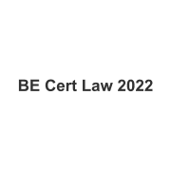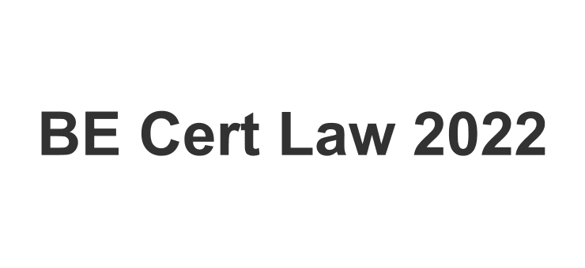
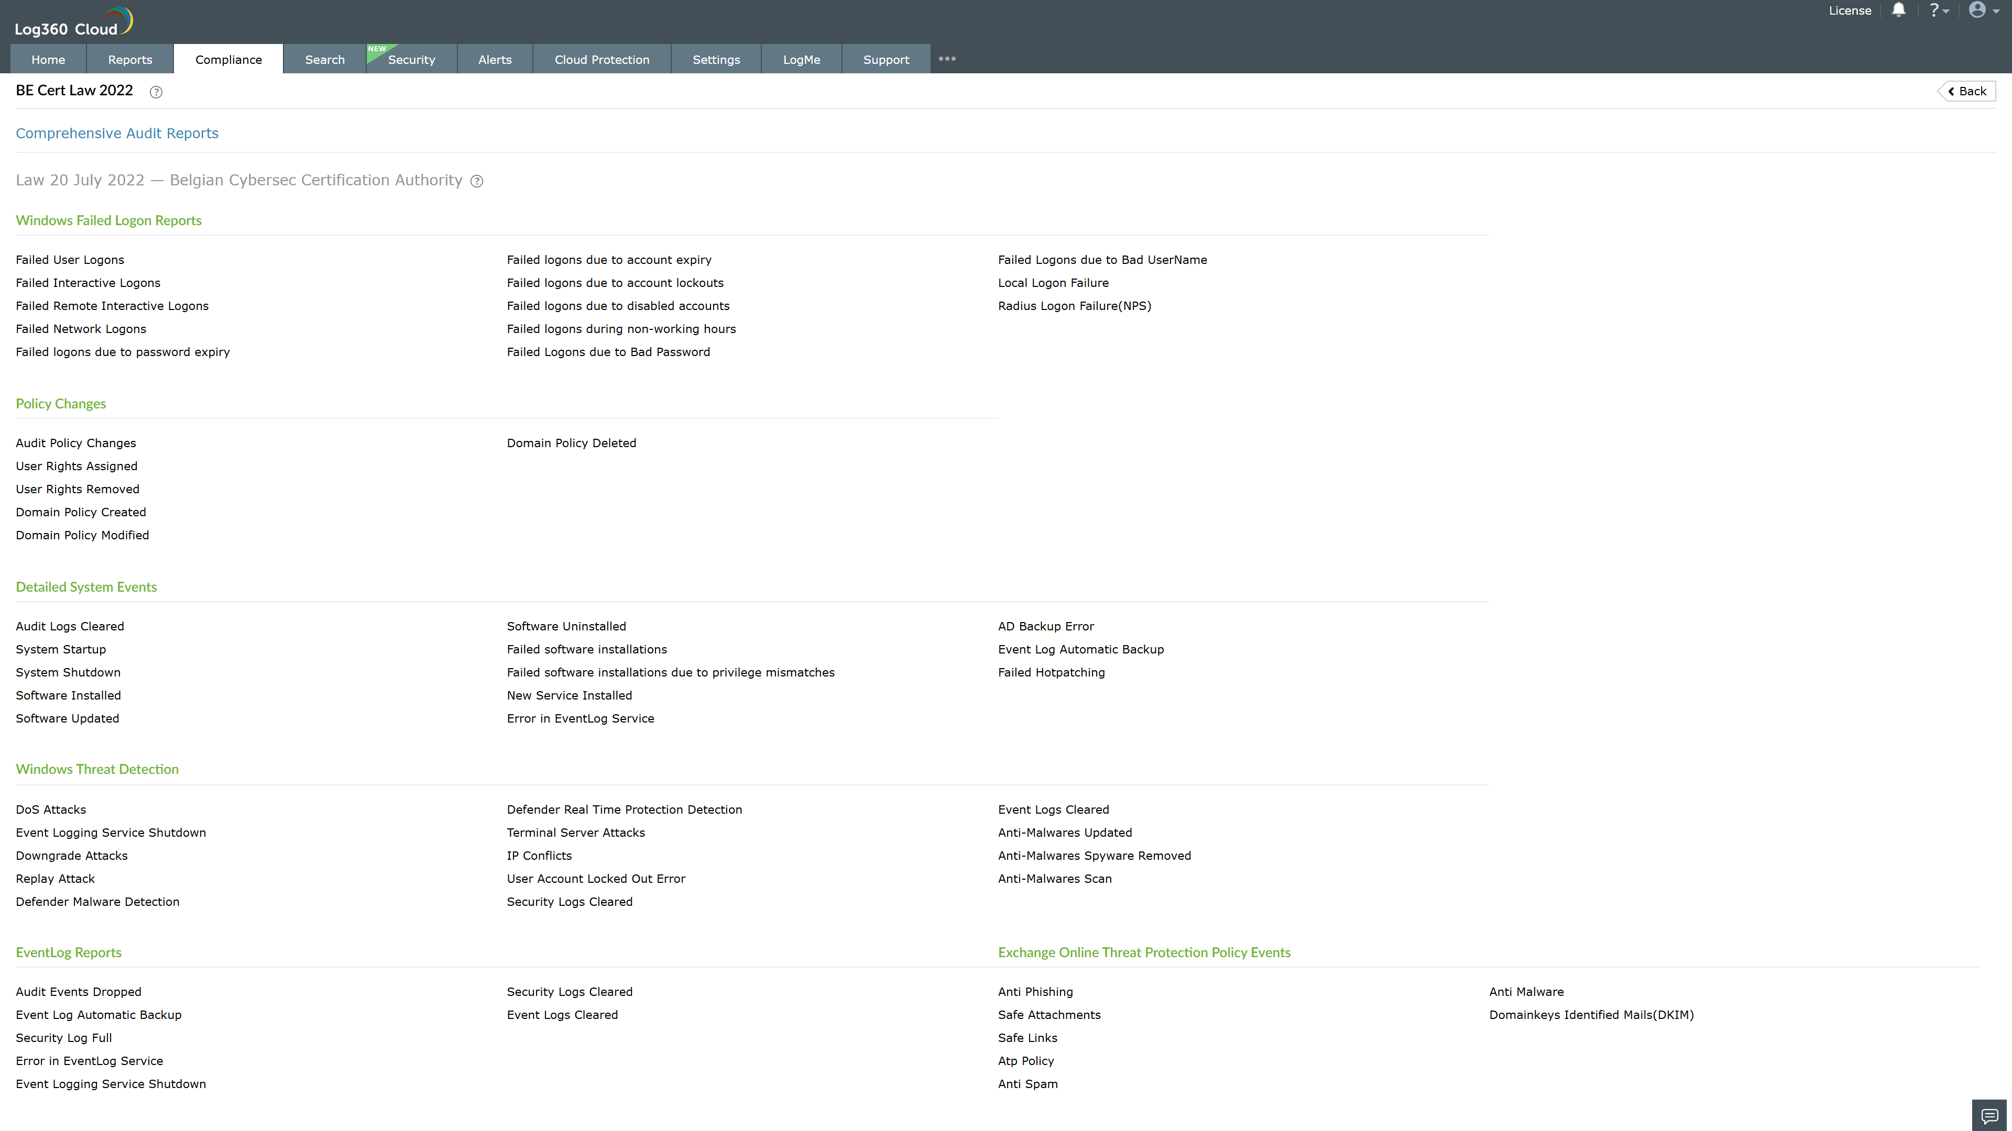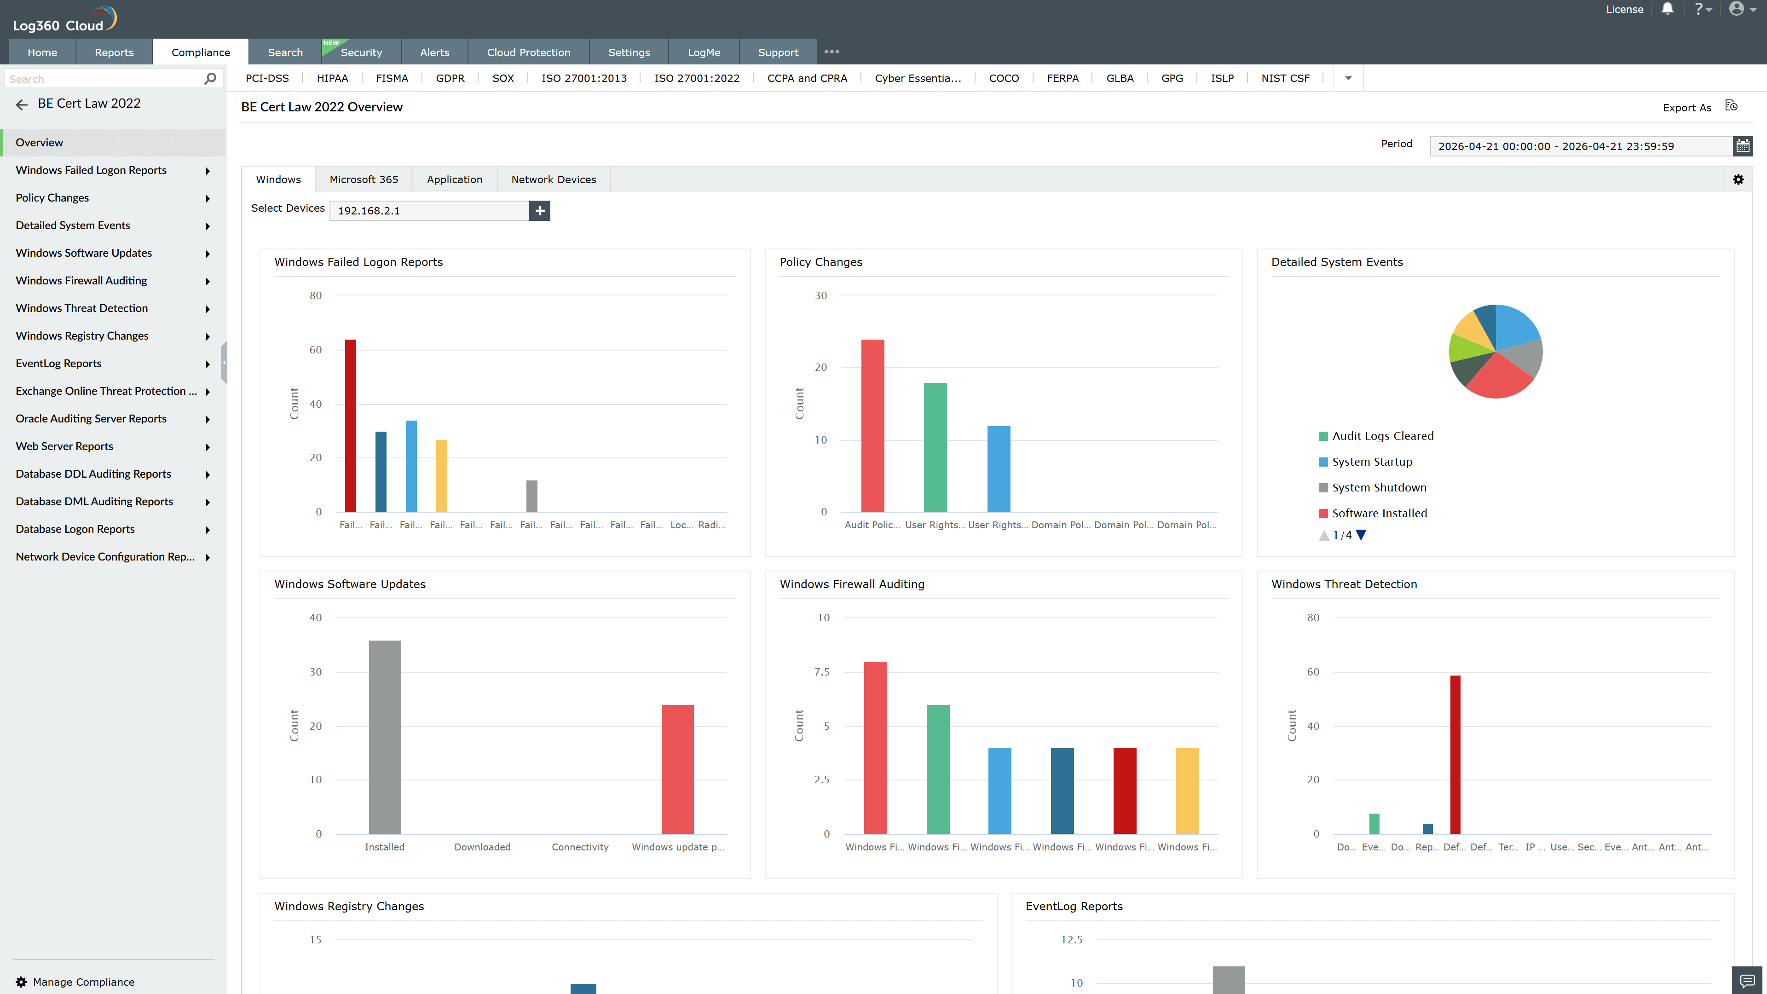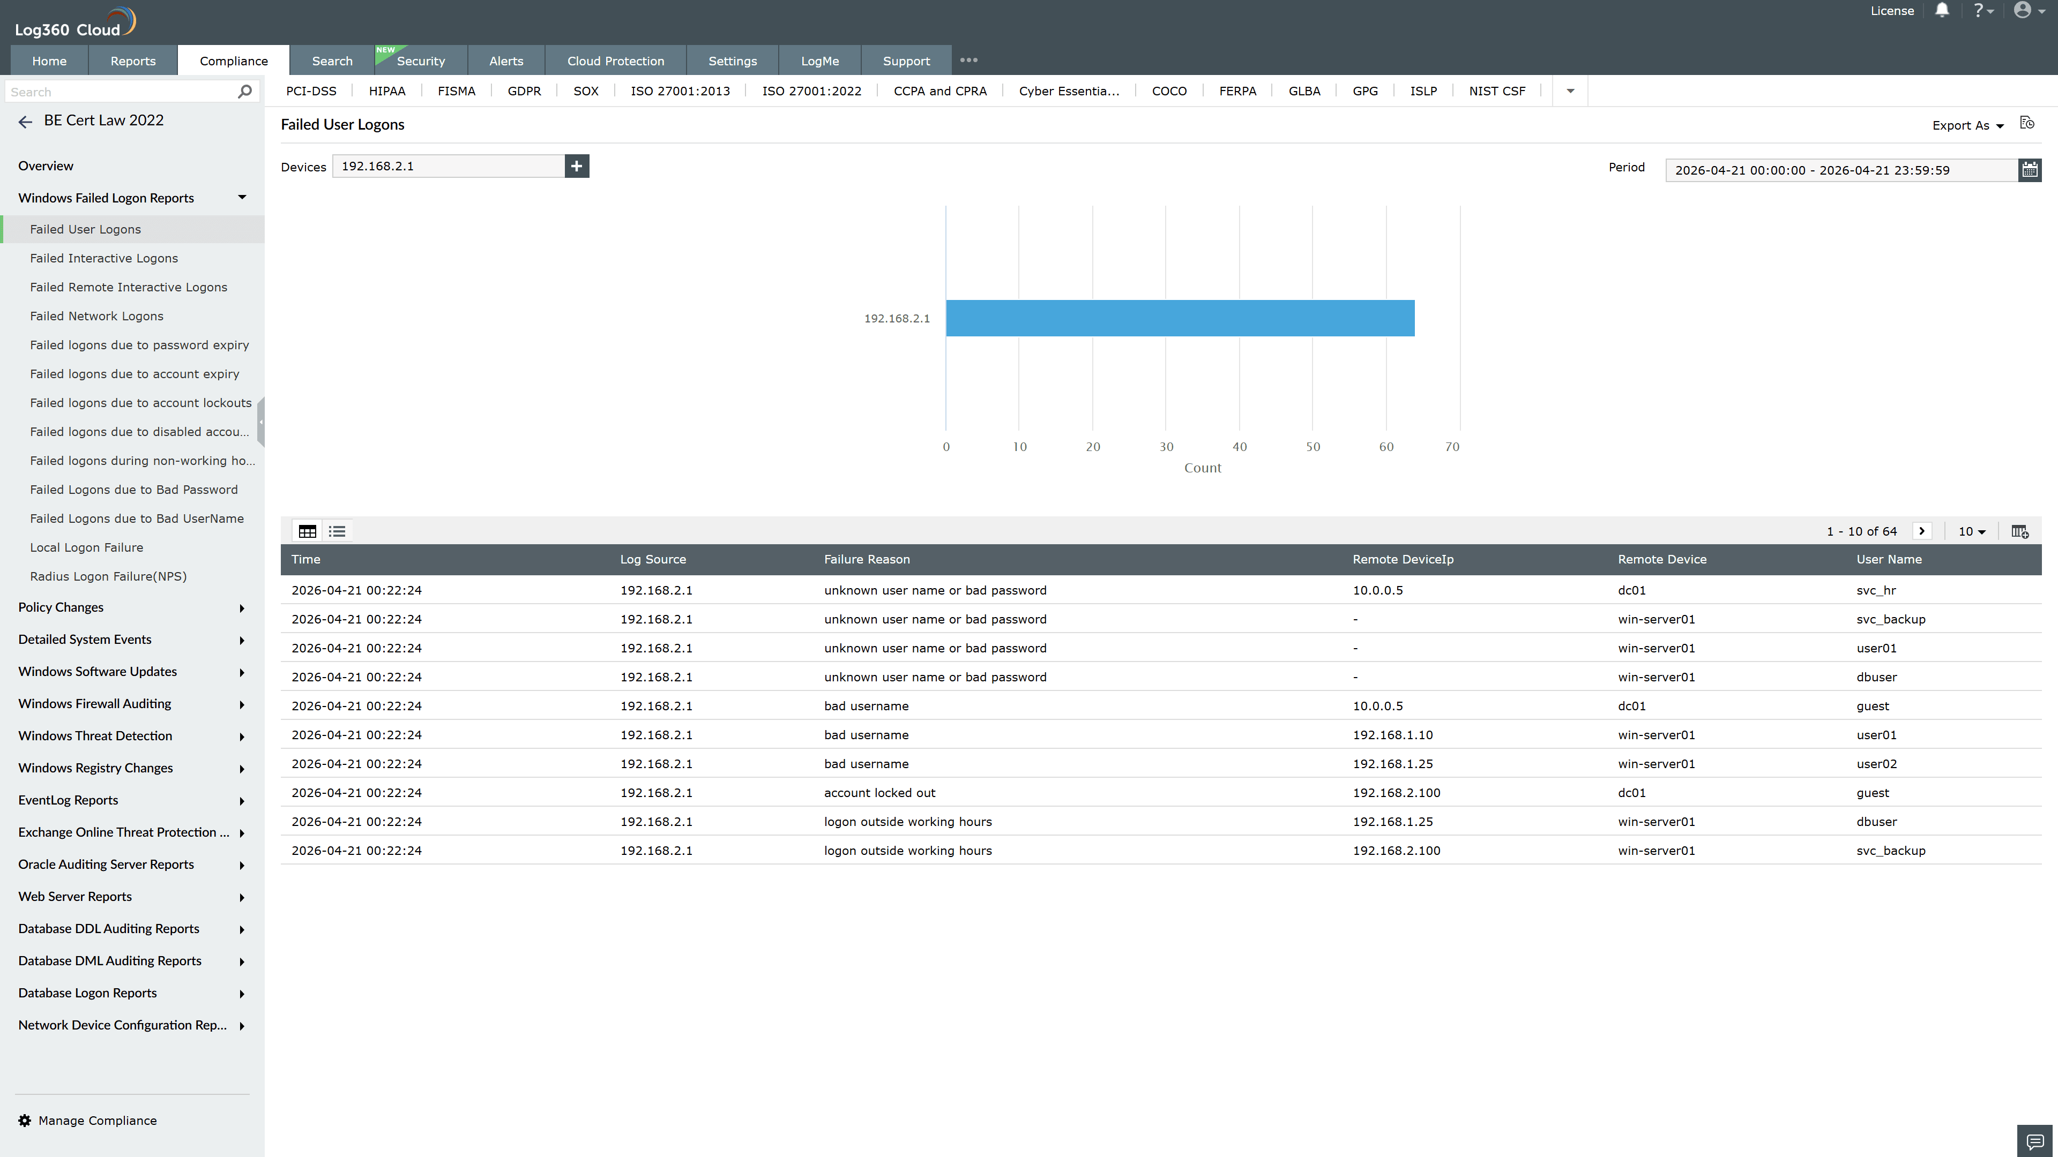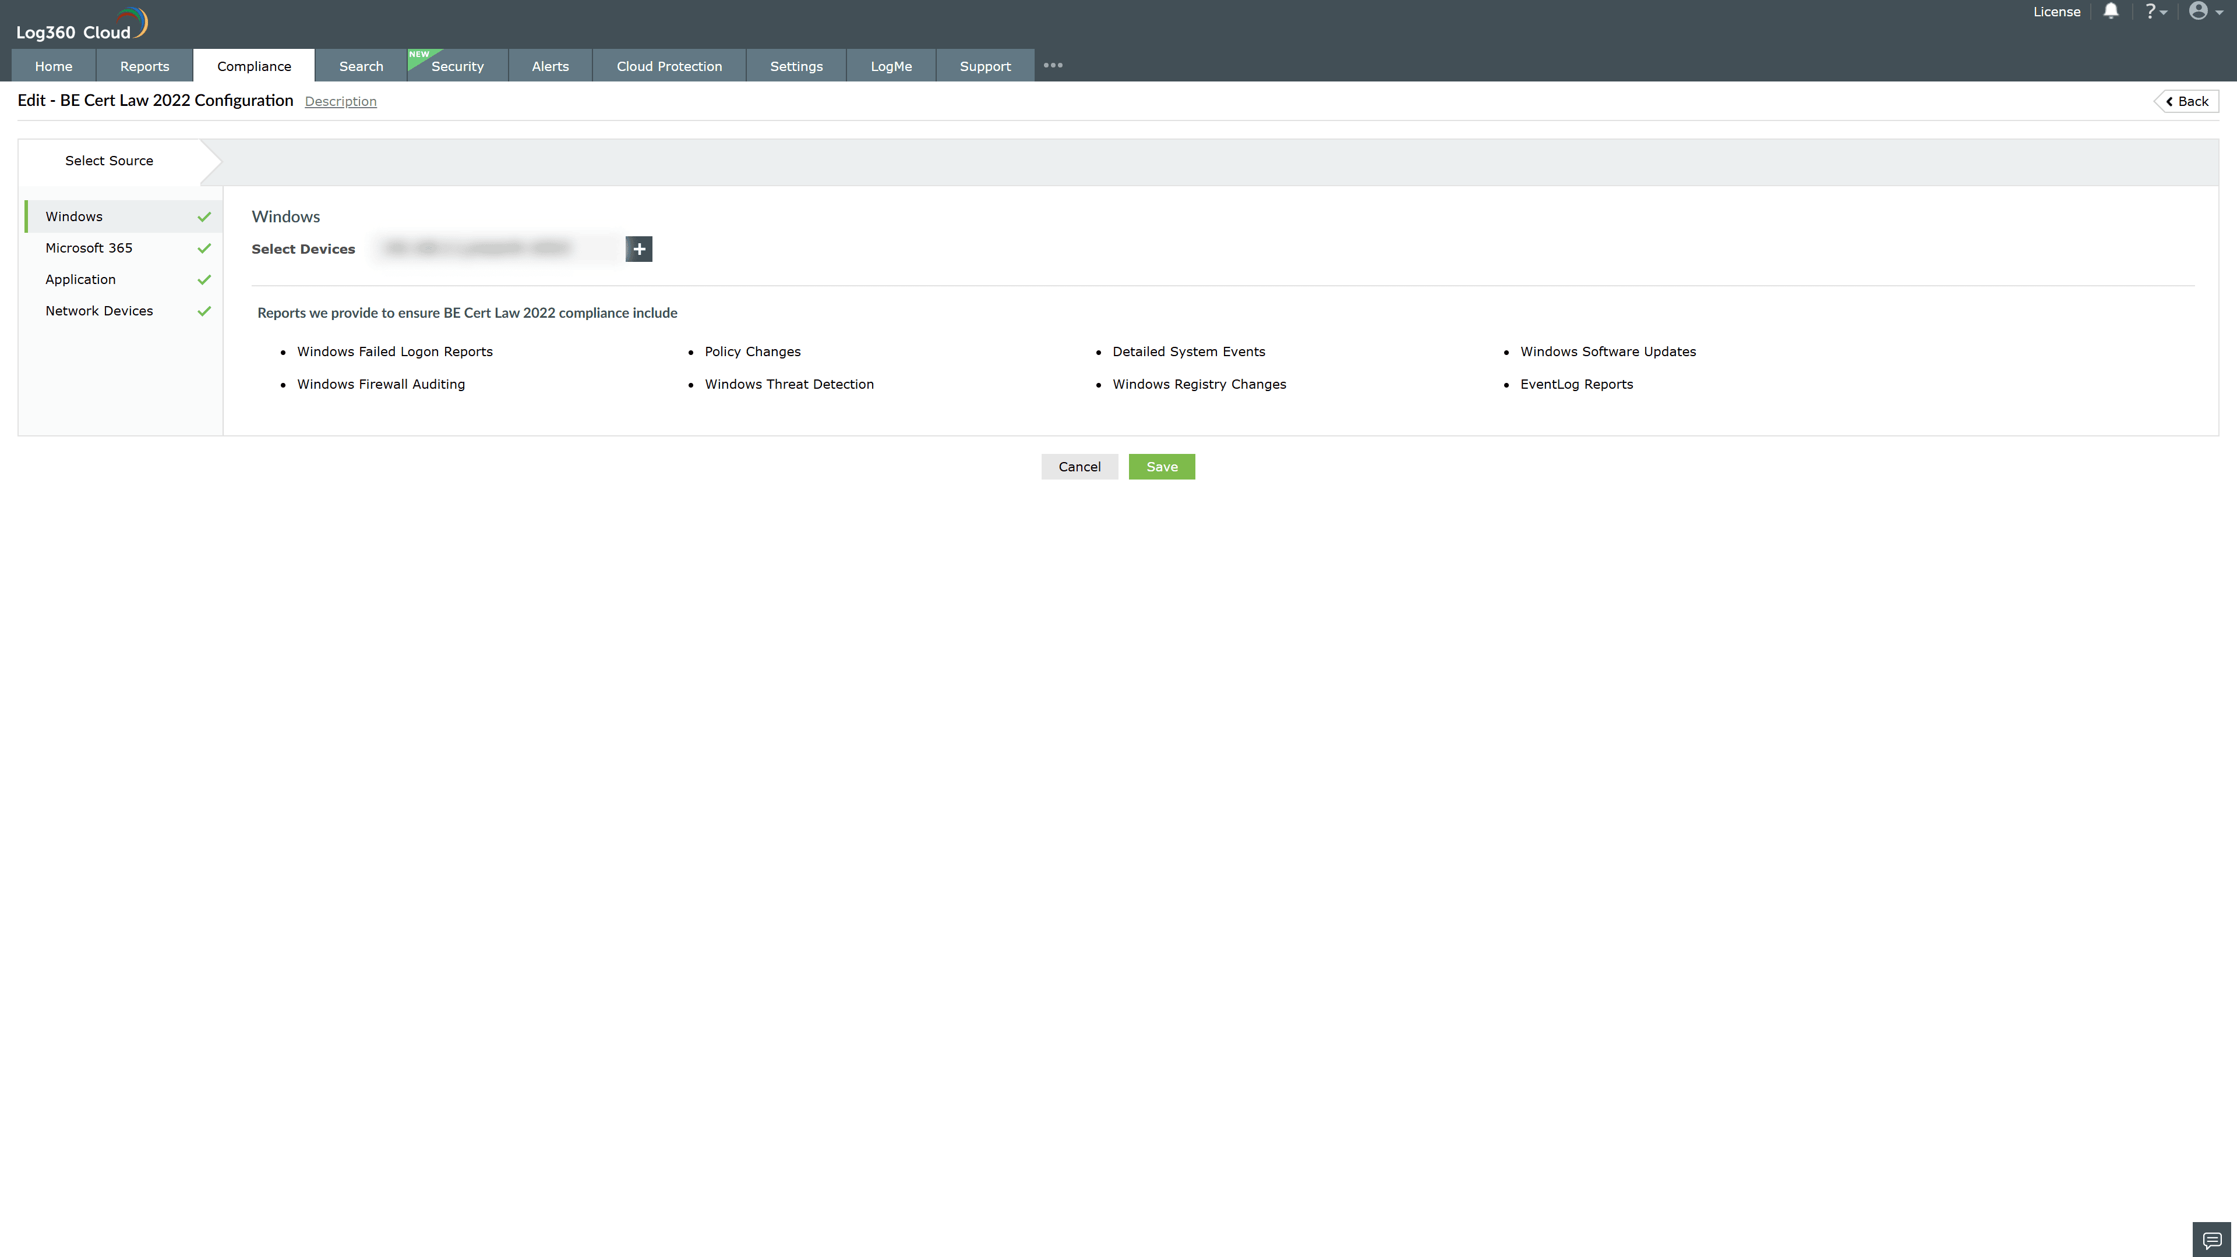
Valid Submission : Yes
Supported Editions : Free, Basic, Standard, Professional, MSSP
Help Document : https://www.manageengine.com/log-management/help/integrations/compliance-extensions.html
Help Video : Not provided
Tags : Log360, Compliance, Privacy monitoring, Data privacy, Regulatory compliance
Supported DCs : US, IN, JP, CA, AU, UK and EU
Privacy Policy:
Terms of Service:
Release Notes:
Predefined reports for the BE Cert Law 2022 Compliance.

